Threat field Plume experimental setup:
Software implementation:
The experimental robotic system was implemented using a modular software architecture centered around ROS 2 (Robot Operating System 2) for inter-process communication and system behavior. Gazebo was employed as the simulation environment, providing a realistic physics-based testbed for evaluating control strategies and response in a virtual context providing ideal conditions for the evaluation of predictive algorithms. PX4 served as the flight control middleware, responsible for executing low-level control loops and modeling realistic actuator and sensor behavior. Intercommunication between ROS 2 and PX4 was achieved via microDDS, a lightweight Data Distribution Service implementation, enabling real-time data exchange between the high-level planning components in ROS 2 and the real-time flight control in PX4.

A custom ROS 2 node was developed to estimate plume concentration in real time, based on the robot's current position within the simulated environment. This node subscribed to the vehicles local position and calculates the concentration at that point using the analytical solution to a instantaneous release time varying plume. These concentration readings are interpreted as virtual sensor readings which are then stored in system memory until there are enough readings to get an overdetermined solution to the inverse gradient concentration equation. These estimated gradient readings are then used for system navigation using a gradient decent algorithm which is them fed back as vehicle rate set points for the system to carry out.

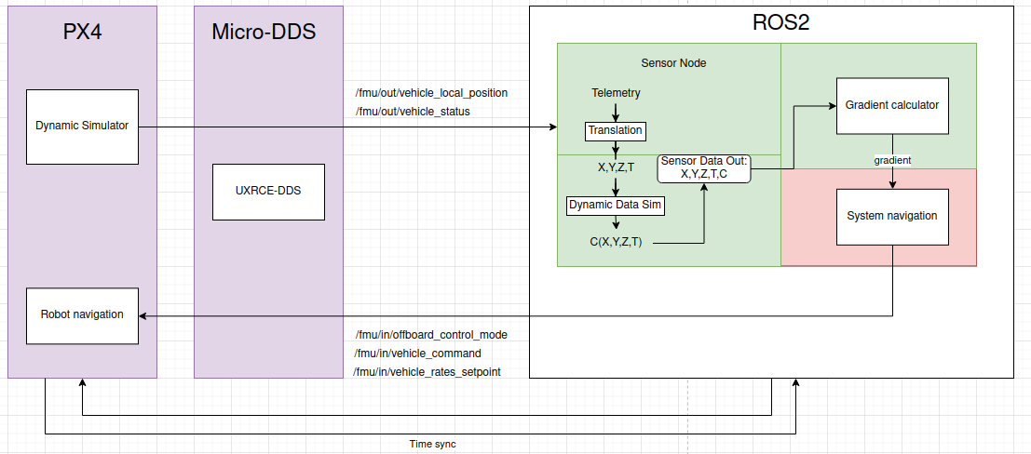Figure 1: software communication architechture
Hardware implementation:
The proposed hardware implementation involves deploying the system on a fixed-wing unmanned aerial vehicle (UAV) equipped for long-endurance environmental monitoring. A Pixhawk series flight controller would be used to interface with the PX4 autopilot firmware, providing reliable low-level control and integration with external sensors and communication modules. A gas concentration sensor, mounted on the airframe and positioned to minimize aerodynamic interference, would provide real-time measurements of plume intensity during flight. Sensor data would be processed onboard using a ROS 2-compatible embedded computer, allowing integration with the existing ROS 2 software stack and enabling plume estimation and guidance algorithms to operate in real time. This theoretical configuration aims to validate the simulation results under real-world conditions and assess the system’s performance in dynamic outdoor environments.
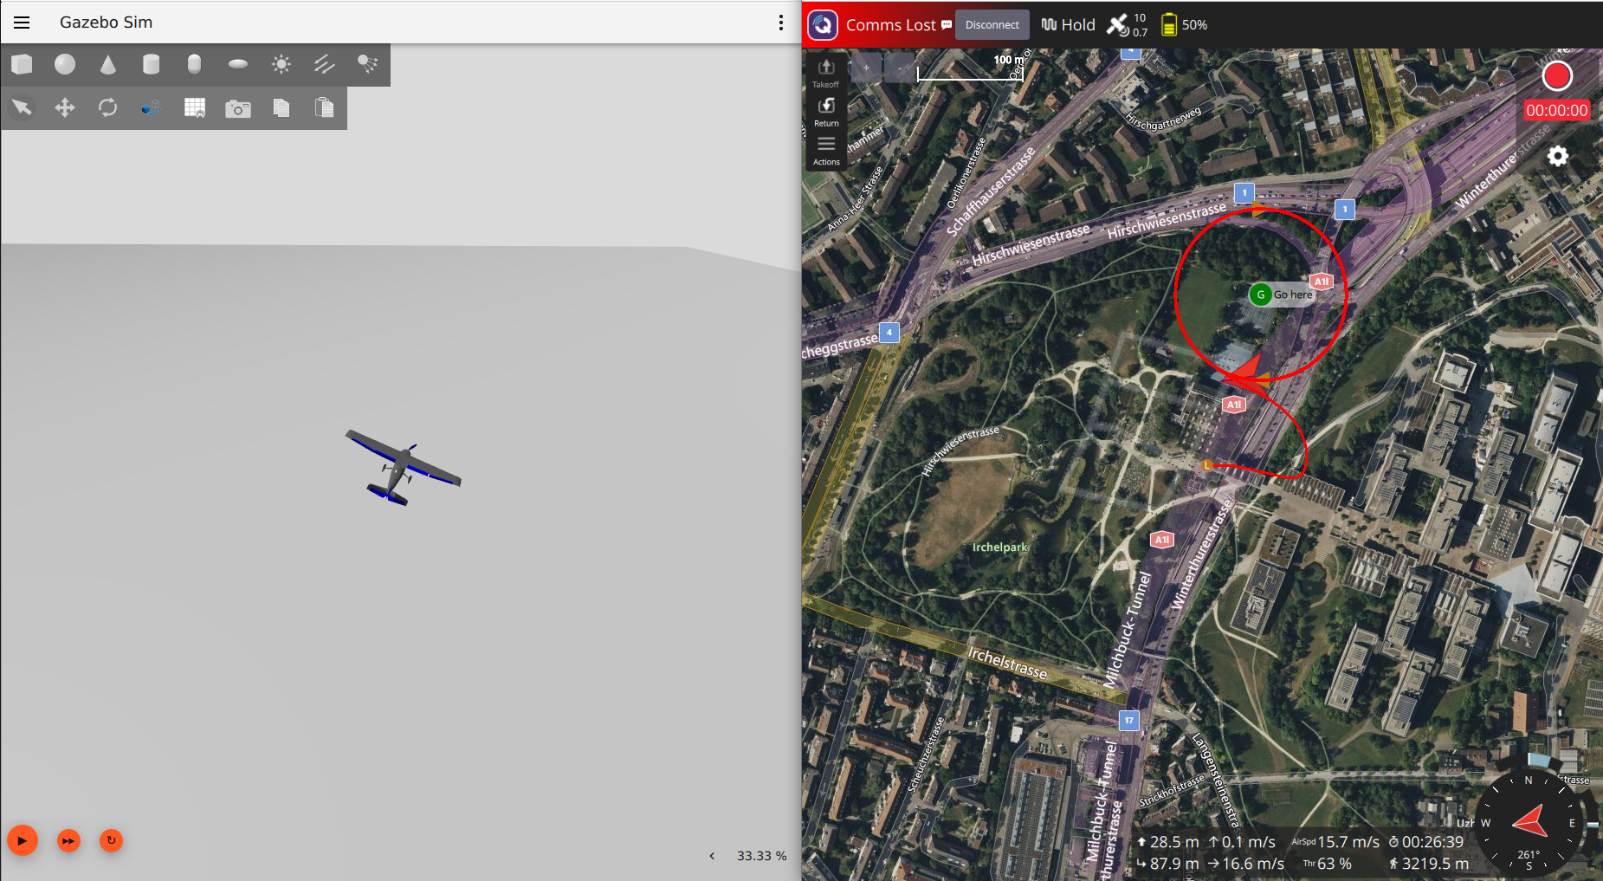Figure 2: software simulation of system showing gazebo simulation on the left and px4 real-world navigation on the right

